Section A: Multiple Choice Questions.
Please read the questions carefully and choose the best answer.
- Identify the INCORRECTLY spelled word in the sentence.
The police found contradictary statements about what happened during the accident.
- accident | - happened
- statements | - contradictary

- The teachers had to make a _________ decision about the upcoming school event.
- fast | - quick
- instant | - hurried

- The weather was __________ for our trip to the safari park.
- excelent | - excellent
- exccelent | - axecellent

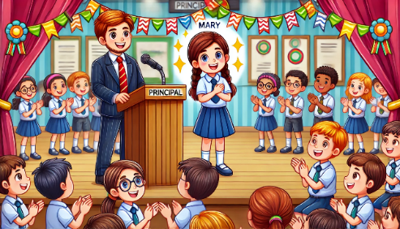

- The principal _________ Mary for her excellent performance in the competition.
- talked | - praised
- spoke | - said

- Mr. Alif gave me _________ honest feedback on my essay during ________ extra class.
- an; a | - a; the
- an; the | - the; the

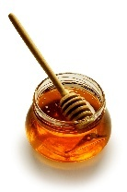
FUN FACT
Honey never ________ because it does not spoil!

- expire | - expires
- expired | - expiring

- We __________ learning about volcanoes in science class.
- is | - are
- was | - were

- My sister asked me to drive __________ to the bus station this morning.
- us | - her
- you | - them

- Among the choir members, James sings the __________.
- better | - beautifully
- more beautifully | - most beautifully

- Complete the dialogue.
Julia: Can you help me work __________ this math problem?
Kim: Sure, I can help you.
- for | - with
- after | - about

- The students in the choir team __________ won the competition received a medal.
- who | - whom
- which | - whose

- Amy _________ her friends at the park every morning for a brisk walk.
- met | - meet
- meets | - had been meeting

- Erica __________ her homework before dinner tonight.
- finish | - finishes
- finished | - will finish

- My favorite food __________ pizza although I also love pasta.
- is | - are
- was | - were

- We have to wait in the car __________ it stops raining.
- thus | - until
- because | - although

- Mr. Samuel __________ the newspaper every morning while having coffee.
- read | - reads
- has read | - is reading

- The teacher __________ the students with a warm smile.
- greet | - greets
- greeted | - greetings

- Laila could not find __________ evidence to show that the boy was guilty.
- any | - much
- some | - lots of

- This has been the greatest day, __________ it?
- has | - had
- hasn’t | - hadn’t

- The bus was delayed due __________ technical failure.
- to | - for
- over | - from

- __________ the bus was late, the students still arrived on time.
- Since | - Unless
- Because | - Although

- Whenever it __________, the road gets flooded.
- rain | - rains
- has rained | - was raining

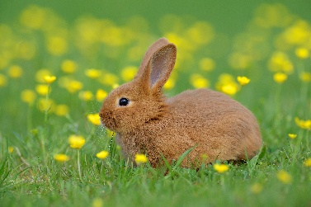

- The rabbit ran __________ across the field to get some food.
- quick | - quicker
- quickly | - quickest

- After months of training, she __________ swim without the kickboard.
- could | - may
- must | - shall

- The mountain path was too __________ for hikers to walk quickly.
- wide | - long
- narrow | - smooth

- We __________ eat fast food at home because our mom cooks every day.
- often | - rarely
- usually | - regularly

- The dog sat quietly __________ the tree because the weather is too hot.
- on | - at
- over | - under

- The Eiffel Tower is crowded __________ tourists all year round.
- by | - with
- over | - from

- Complete the dialogue with a suitable response.
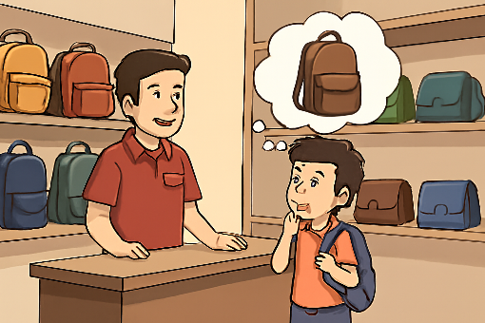
_______

Yes, I am looking for a new bag.

- This is a new bag.
- Can I help you with anything?
- We have a variety of bags available.
- Would you like to have a seat first?

- Complete the dialogue with a suitable response.
________.
I am planning to go to the cinema tonight.
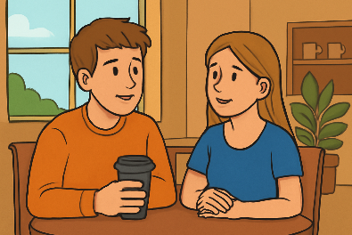

- I usually go to bed early.
- Great! Tomorrow is a holiday.
- What movie are you going to watch?
- I have already finished my homework.

Section B : Read the passage and fill in the blanks with the best answer.
In today’s world, children __________(31) more time using screens than ever before. Although television and digital games can be enjoyable, too much screen time may __________ (32) on regular physical activity. Experts recommend that children should get at least one hour of active play each day, but many end up sitting for hours instead.
Playing outdoor games not only __________ (33) improve fitness but also builds social skills and boosts mood. When children play outside, they often use their imagination, which encourages them to be more creative. __________ (34), watching too much television may lead to poor posture, lack of focus and even sleep problems.
To enjoy a healthy and happy childhood, it is important to balance screen time with outdoor activity. After all, the best adventures and memories are often made when you step outside and __________ (35) the world around you!
- spent | - spend
- spends | - spending

- cut off | - cut out
- cut back | - cut down

- help | - helps
- helped | - helping

- Also | - Because
- However | - Therefore

- explore | - explores
- explored | - exploring

Section C: Read the statement carefully and choose the answer that has the CLOSEST meaning.
- Many species of birds migrate thousands of kilometers each year to find warmer climates and abundant food sources.
- Birds migrate mainly to avoid cold weather.
- All birds migrate the same distance every year.
- Migration helps birds survive seasonal changes.
- Birds migrate only when food in the area is scarce.
- Hydroponic farming allows plants to grow without soil and is commonly used in cities where space for traditional farming is limited.
- Plants that are grown hydroponically are less healthy.
- Soil farming is more popular in cities than hydroponics.
- Urban farming can only be done in a small farming area.
- Hydroponic offers a solution for growing plants in small areas.
- Glowing plankton are tiny sea creatures that produce light, causing the ocean to glow when the water is disturbed at night.
- Glowing plankton light up only when it rains.
- The planktons help humans to find their way.
- Glowing plankton is a reflection from the moon.
- Water movement triggered the plankton to glow.
- Although most people brush their teeth twice a day, many do not brush for the recommended duration or replace their toothbrush regularly.
- Brushing twice a day ensures perfect dental health.
- Toothbrushes should be used for several years continuously.
- Dentists never give proper recommendations to their patients.
- People may have poor dental hygiene even if they brush regularly.
- Magic Kingdom at Walt Disney World has underground tunnels that allow workers to move around the park without being seen by guests.
- The tunnel helps to keep the park safe for guests.
- Workers use the tunnel to surprise guests during shows.
- The tunnel helps improve the guest experience in the park.
- Guests may use the tunnel to meet their favorite characters.

Section D : OPPOSITE Word.
- Read the riddle and answer the question.
I am freedom, the power to make my own choice. What is my opposite?

- constraint | - leadership
- entitlement | - disagreement

- Identify the correct antonym pair.
- furious – angry | - expand – shrink
- vacant – empty | - confuse – puzzled

- The scientists were trying to transform the arid land into a place where food could be grown.
- rocky | - fertile
- barren | - muddy

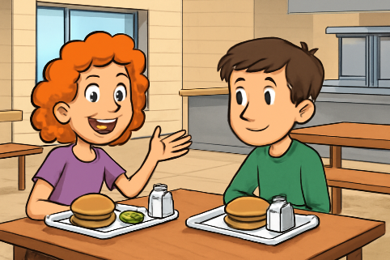
- Read the dialogue and find the antonym for the underlined based on the situation.
I love how energetic you are today!
__________.

Thanks! Yesterday I felt really ____.

- bright
- upbeat
- sluggish
- motivated

- Look at the news item and choose the best antonym.
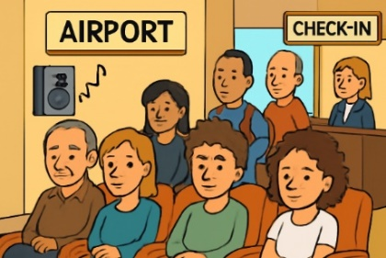
“The peaceful background music helped to calm the restless crowd at the airport.”
- serene
- agitate
- confuse
- distract

Section E : Read the question carefully and choose the best answer for each question.
- What is the correct prefix to add to the word “mature” to make it mean “not mature”?
- in | - un
- im | - dis

- Which word describes the action of returning something to its original condition or state?
- repair | - return
- restore | - resume

- Henry spent his afternoon walking along the water__________ to get some fresh air.
- fall | - line
- way | - front

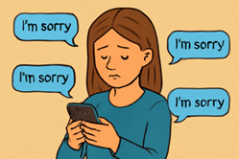

- Sandra tried to _________ for her mistakes by apologizing to everyone.
- set off | - get over
- make up | - keep off

- Complete the sentence with the correct idiom.
Peter was ______________ when he said he is moving to London.
- pulling my leg | - breaking the ice
- biting his tongue | - missing the boat

